**Real time object tracking and motion capturing**

-Using Computer Vision

**OBJECTIVE**

Main aim of this project is to develop a software that can track an object( a pen) in real time and track its motion through lines so that the object or a pen can act like a virtual pen on a white board which can be used while teaching to draw various figures and pointing out to various parts of the screen in real time. The computer vision algorithm should aptly do this without causing hassle to the user and disturbances to the viewers.

* Users can draw figures in real time.
* Users can use this as a virtual pen.
* Users can clear the screen.
* Users can clear the whiteboard and redraw the figures.
* Users can save the whiteboard as an image for later use.

**INTRODUCTION**

“Real Time Object Tracking and motion capturing using computer vision” is a computer vision based project developed to use any specific kind of pen as a virtual pen that can be used in real time, while teaching and demonstration. User gets to use his personal pen instead of sophisticated and expensive virtual pens which use the laser beams to point out things implicitly on the computer or the projector screen. This kind of pen kills the need of such expensive setup and uses a generic software that is platform independent. The software has been developed on Jupyter notebook which is an IDE for developing machine learning softwares also and the programming language used is Python implementing “Computer Vision”.

This is a modelled version of such proposed setup (so it won't be a standalone virtual pen at this moment) but still - it will demonstrate the functioning of a virtual pen with added enhancements. And the key word here is real time, because the software will not be given any preset image to work upon rather it will use our built in laptops webcam to get real time video frames and detect our pen - so that we can use it to draw lines and figures. All this will happen so flawlessly that it will look like the pen is electronically integrated to the laptop, but it will not be. The laptop will use the webcam to detect our predefined object.

Computer Vision is the result of combining Machine Learning, artificial intelligence and the computers own vision i.e camera frames. This is done using an open source library named OpenCV. OpenCV has some built in libraries that help in using our camera frames as inputs to detect and manipulate them. This library can also be used to manipulate images we have also done that in this project.

The basic principle between the object tracking of this project is that this project uses the concepts of contour and image segmentation in computer vision to detect objects and in our case a pen. Image Segmentation is the process in which we isolate our desirable part of the image from the whole image and then our algorithm to detect whether this part of our image is the desirable image or not. OpenCV uses machine learning to perform this task based on the specification of the desirable object we want to work upon. Then this software calculates the centroid of this segmented image of the desired object. These centroids have x and y co-ordinates. These co-ordinates are then stored in a numpy array which we import from the numpy library of python which is modified by anaconda package. Then lines are drawn between these points which represent the shapes we want to draw on the screen.

**KEYPOINTS :**

* It is developed using Python Programming Language.
* It is developed in Jupyter IDE.
* Easy maintenance and user friendly application.

**PROBLEM STATEMENT**

The idea behind making this project was that in today’s world as it is moving towards a digital revolution everything is demonstrated through presentations charts be it in the field of teaching or marketing presentations etc. The presentations on the big screen require something to point out

the daily driver for this problem is a laser based pointer which points to the position we want to point on the screen but this kind of pointers are very expensive and the they point things implicitly that means it isn’t the perfect solution to the problem and everything it does, it does it physically for the user’s eye and nothing is stored on the computer screen and we cannot capture our movements through that. We cannot also use it to draw figures and shapes.

This project proposes an alternative to this by reducing the overall cost of daily use and greatly increased functionality. We can use our own pens which we use to write on our notebooks as virtual pens to point something on the screen draw figures and objects on the computer screen and use it as a whiteboard marker or a blackboard chalk for teaching. This software also minimises the uses of marker pens and chalks to draw on boards and this is very beneficial as they have a finite capacity of use and need to be replaced every now and then. It is also very interesting to know it needs nothing now just a laptop with a working webcam. Which is a one time investment and most of the people around the world have already made this investment and are using them for their everyday use. The type of pen it uses can also be adjusted to suite your specific type of pen. This product has the capacity to revolutionise the whole concept of using physical pens, markers, chalks and expensive laser pointers.

**SOFTWARE REQUIREMENT**

**SPECIFICATION (SRS)**

**Purpose**

**“**Real Time Object Tracking and motion capturing using computer vision” is a computer vision based software developed to use users own specific pen as a virtual pen. User gets to draw shapes figures and lines on the computer screen. The software has been developed on the programming language Python implementing computer vision.

**Technologies Used**

* Computer Vision: Computer vision is that the science that aims to present an identical, if not higher, capability to a machine or a PC.
* Numpy arrays: The numpy arrays are grids of values, all of a similar kind, and is indexed by a tuple of positive integers. the quantity of dimensions form the rank of the array; the former shape of array could be a tuple of integers giving the scale of the array on every dimension.
* OpenCV: OpenCV, a library of programming functions principally aimed towards real-time computer vision. Originally developed by Intel, was later supported by Willow Garage then Itseez. The library is cross-platform and free to be used with the open source BSD license.
* Contours: Contours are often explained as a curve combining all the continual points (along the boundary), having same colour or intensity. The contours can be a great tool for form analysis and object detection and recognition.

**Product Scope**

* Making different shapes and figures.
* Making our pen to point out to different points on the screen.
* Making this project to clear previous written thing.
* Making this project to save work as an image for later use.
* Making this project more graphic intensive.
* Make this project even more stable.

# Overall Description

# Product Perspective

* Module 1: Canvas maker - It makes a white image of 700 X 1000 every time the project is initialised.
* Module 2: Image capturing and object detection - It is used to open the webcam and process the frames received from it to detect our object and perform tasks with it.
* Module 3: Close Project - When the enter key is pressed the project is closed the camera is released and our whiteboard is saved as an image named whiteboard.png .

## Product Functions

This is a modelled version of our proposed setup (so it won't be a standalone virtual pen at this moment) but still - it will demonstrate the functioning of a virtual pen with added enhancements. And the key word here is real time, because the software will not be given any preset image to work upon rather it will use our built in laptops webcam to get real time video frames and detect our pen - so that we can use it to draw lines and figures. All this will happen so flawlessly that it will look like the pen is electronically integrated to the laptop, but it will not be. The laptop will use the webcam to detect our predefined object.

## Operating Environment

There are no specific test cases. The user can draw the figures and shapes as he wishes and then he can see the figures he made through his pen.

## Design and Implementation Constraints

The basic principle between the object tracking of this project is that this project uses the concepts of contour and image segmentation in computer vision to detect objects and in our case a pen. Image Segmentation is the process in which we isolate our desirable part of the image from the whole image and then our algorithm to detect whether this part of our image is the desirable image or not. OpenCV uses machine learning to perform this task based on the specification of the desirable object we want to work upon. Then this software calculates the centroid of this segmented image of the desired object. These centroids have x and y co-ordinates. These co-ordinates are then stored in a numpy array which we import from the numpy library of python which is modified by anaconda package. Then lines are drawn between these points which represent the shapes we want to draw on the screen

## Dependencies

* Python - The programming language used for this project.
* Jupyter IDE - The IDE used for the project
* OpenCV - a library of programming functions principally aimed towards real-time computer  vision. Originally developed by Intel, was later supported by Willow Garage then Itseez. The library is cross-platform and free to be used with the open source BSD license.
* Numpy - NumPy is a library for the Python programming language, adding support for large, multi-dimensional arrays and matrices, along with a large collection of high-level mathematical functions to operate on these arrays.
* Anaconda - Where packages, notebooks, projects and environments are shared. Powerful collaboration and package management for open source and private projects.

# External Interface Requirements

## User Interfaces

The user can requires to have anaconda and Jupyter IDE as well as numpy installed on his system

## Software Interfaces

Windows 10+

Mac OS X +

Linux

# System Features

## System Feature

The system should have a working webcam to capture camera frames in real time which can be used to draw figures and obstacles on the screen. The camera should be at least a 720p HD camera for the best performance though it will work on almost all kinds on webcams.

The system should have the hardware capability to run the anaconda and the jupyter notebook as these softwares take a great toll on the hardware systems due to their complexity.

# Other Nonfunctional Requirements

## Performance Requirements

The user can draw the figures as he wishes and then he can see the figures form on the screen. This software requires a windows 10 (or above) or Mac OS X (or above) or Linux.

## Safety Requirements

There are no such safety requirements. This software is safe for every person above the age of 3+.

## Security Requirements

There are no such security requirements. This software is completely secure.

## Software Quality Attributes

The software runs in full quality across all parameters which satisfy the minimum requirements.

## Business Rules

This software is completely open source. There are no business rules.

# Other Requirements

There are no other requirements as this project is completely stand alone and open source

**ENTITY RELATIONSHIP DIAGRAM**

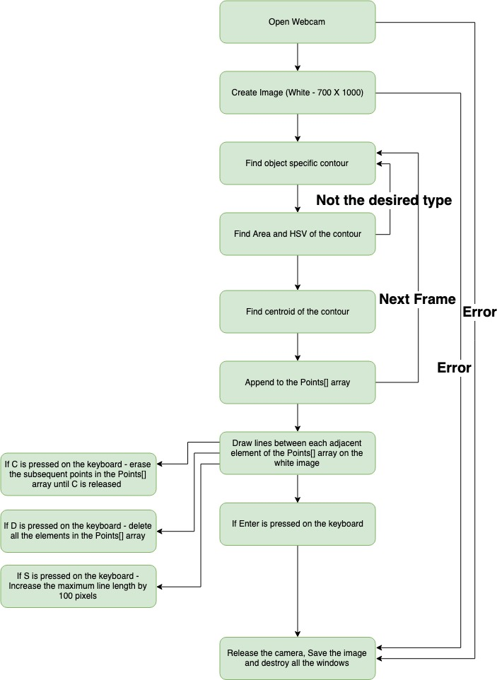

**TEST CASES**

**No Figures**

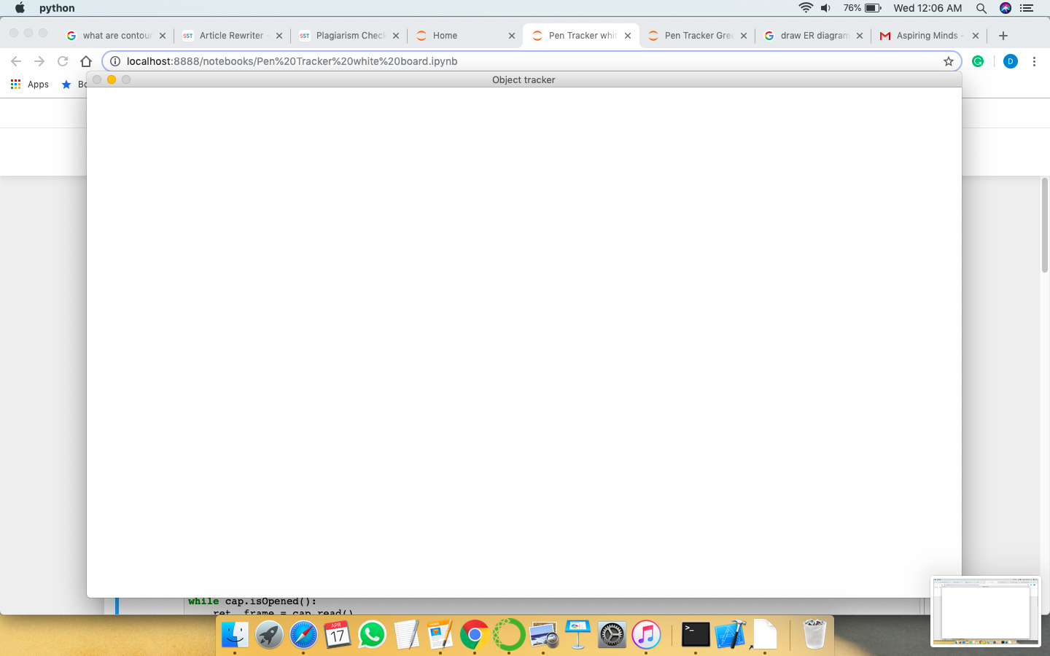

**Some** **Figures**

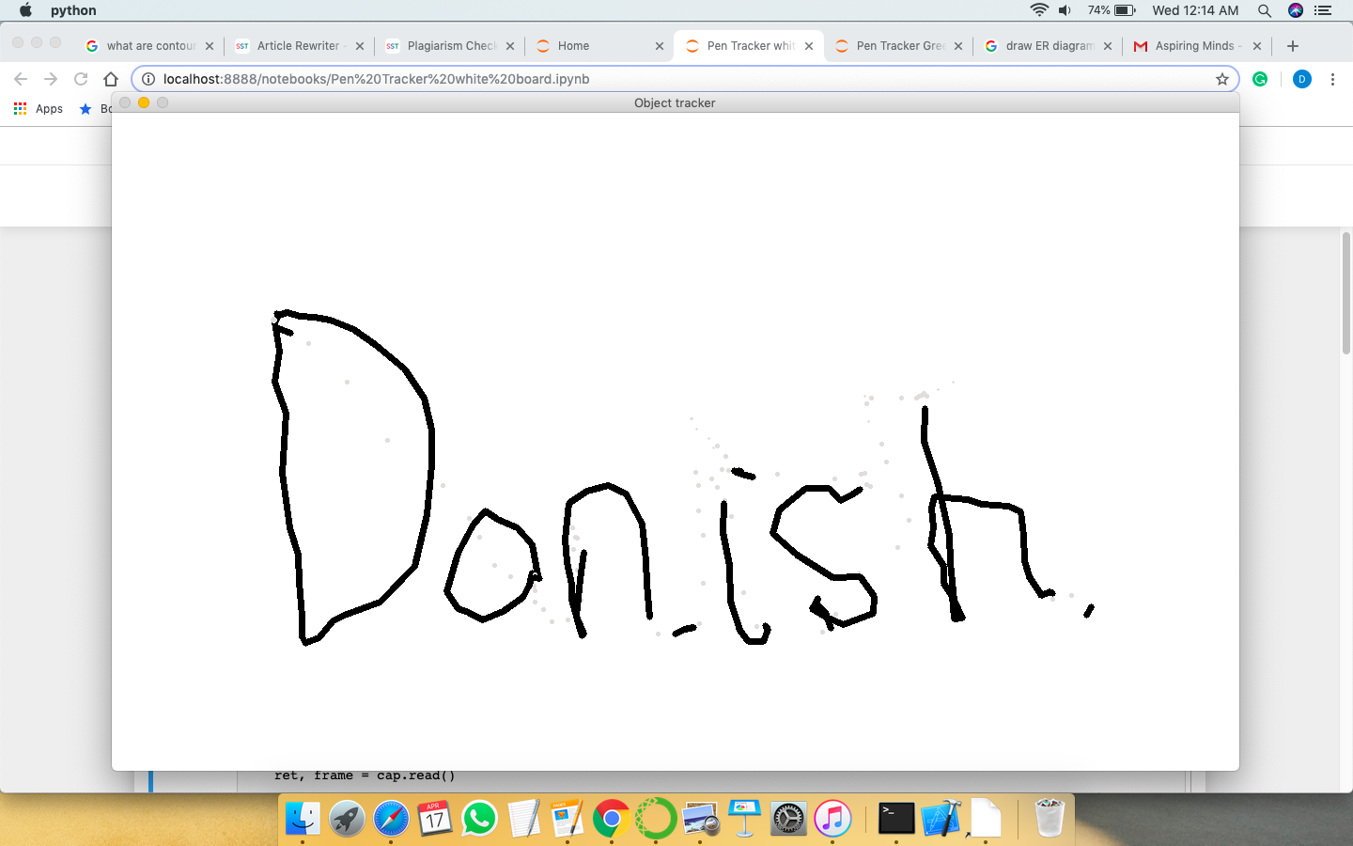

**Full Lines and figures**

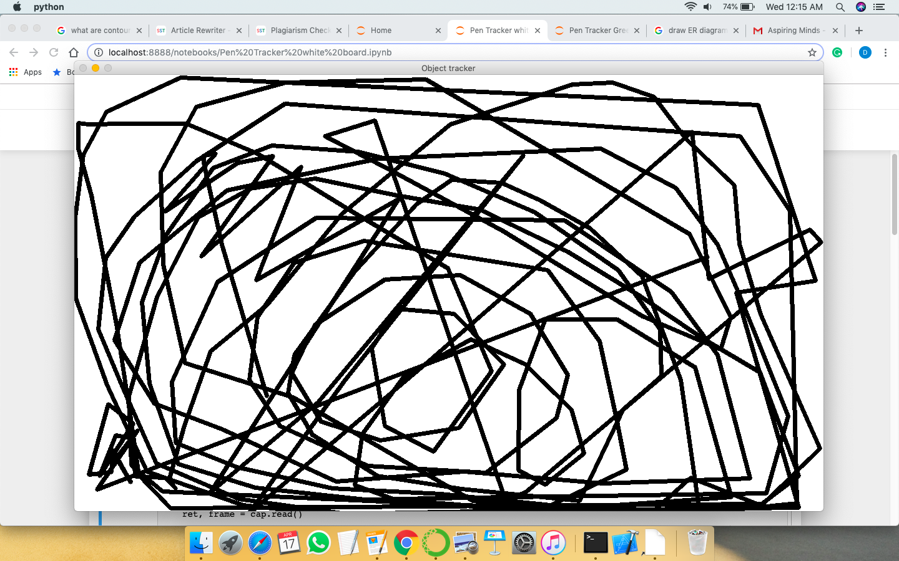

**SCREENSHOTS**

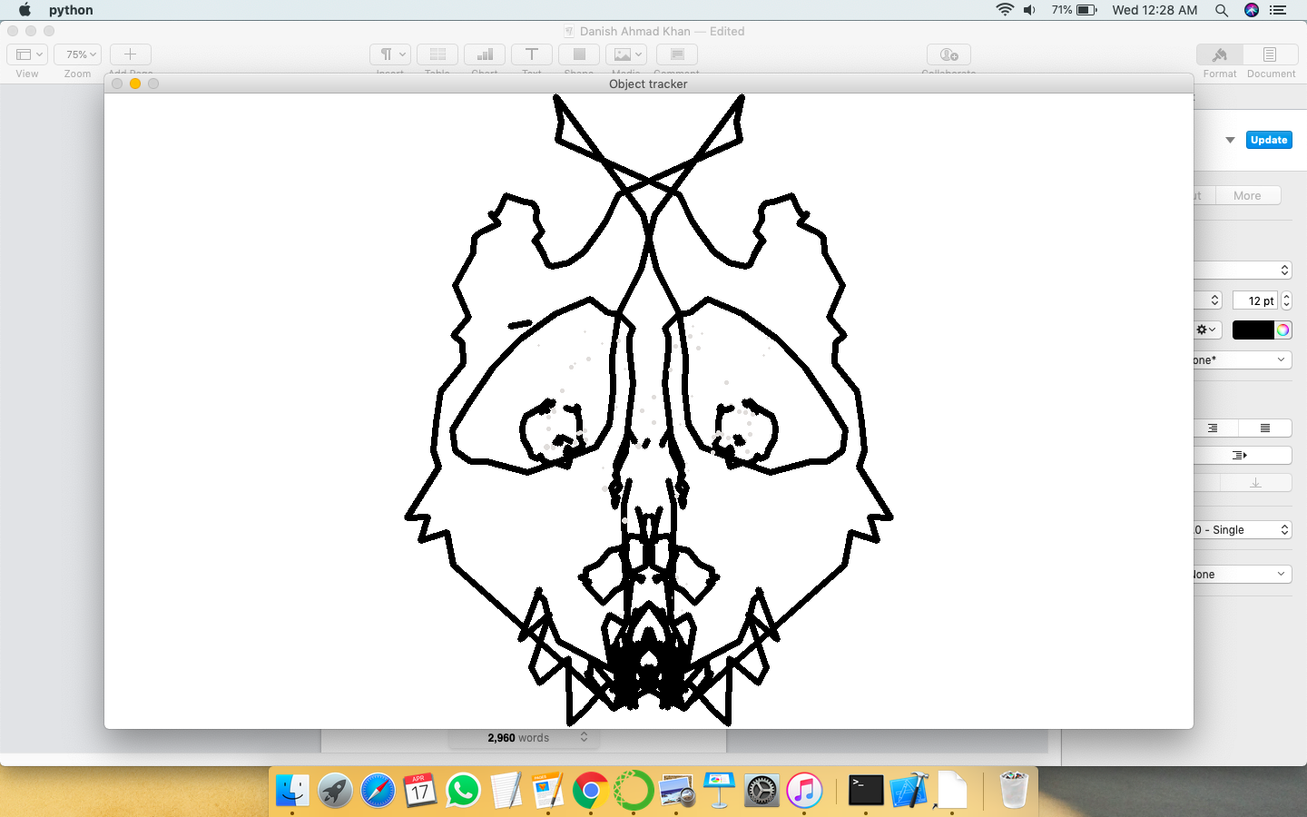







**TECHNOLOGIES USED**

**Computer Vision -** Computer vision is an inter-disciplinary field that deals with in what methods machines may be made to realise high-level knowledge from digital photographs, videos or live cam feeds. From the angle of engineering, it seeks to automatise tasks that the human sensory system do.

Computer vision tasks exemplify techniques for getting, handling, examining and understanding advanced pictures, and extraction of high-dimensional learning from this present reality so as to give numerical or emblematic information, e.g., in the types of exact choices. Conceptualising in this setting implies changing the visual pictures (the contribution to the eyes) into portrayals of the universe that might be joined with various points of view and adept adequate activity. This picture understanding is frequently observed in light of the fact that the unraveling of emblematic information from picture data utilising models made with the assistance of unadulterated arithmetic, geometry, material science, measurements, and learning hypothesis.

As a field of study, computer vision cares with the speculation behind artificial systems that extract info from pictures. The image information can take various forms, like video sequences, views from multiple cameras, or multi-dimensional information from a medical scanner. As a technological discipline, computer vision seeks to use its theories and models for the development of computer vision systems.



**OpenCV**- OpenCV (Open source computer vision) means a library of programming functions  principally aimed toward real-time computer or machine vision. Originally developed by Intel, it had been later supported by Willow Garage then Itseez (which was later bought by Intel).

It supports machine learning frameworks such as Google TensorFlow, PyTorch, and Caffe.

Launched in 1999, the OpenCV project was at first Intel research-cum-analysis initiative to advance CPU-intensive applications, a part of a series of projects together with real-time ray tracing and 3D digital walls. the principle contributors to the project came together with a variety of optimisation specialists in Intel Russia, in addition as Intel's Performance Library Team. in the initial days of OpenCV, the goals of the project were represented as: Advance vision analysis by providing not solely open however additionally optimised code for basic vision infrastructure. No additional reinventing the wheel. Disseminate vision information by providing a typical infrastructure that developers might rest on, so code would be additional without delay decipherable and transferable. Advance vision-based industrial applications by creating moveable, performance - optimised code on the market for free of charge – with a license that didn't need a code to be open or free itself.The first alpha version of OpenCV was free to the general public at the IEEE Conference on pc Vision and Pattern Recognition in 2000, and 5 betas were free between 2001 and 2005. the primary one.0 version was free in 2006. A version one.1 "pre-release" was free in Oct 2008.

The second major unleash of the OpenCV was in Oct 2009. OpenCV two includes major changes to the C++ interface, aiming at easier, additional type-safe patterns, new functions, and higher implementations for existing ones in terms of performance (especially on multi-core systems). Official releases currently occur each six months associate degreed development is currently done by a freelance Russian team supported by industrial firms.In August 2012, support for OpenCV was confiscated by a non-profit foundation OpenCV.org, that maintains a developer and user web site.On might 2016, Intel signed associate degree agreement to accumulate Itseez, a number one developer of OpenCV. OpenCV is written in C++ and its primary interface is in C++, however it still retains a less comprehensive although-in depth older C interface. Their area unit bindings in Python, Java and MATLAB/OCTAVE. The API for these interfaces is found within the on-line documentation. Wrappers in different languages like C#, Perl, Ch, Haskell, and Ruby are developed to encourage adoption by a wider audience.Since version three.4, OpenCV.js could be a JavaScript binding for selected set off OpenCV functions for the net-platform. All of the new developments and algorithms in OpenCV area unit currently developed within the C++ interface.



**Image Segmentation -** In computer vision, it is the way toward parceling a computerised picture into various sections (sets of pixels, otherwise called super-pixels). The objective of division is to disentangle or potentially change the portrayal of a picture into something that is increasingly important and simpler to analyse. It is ordinarily used to find items and limits (lines, bends, and so on) in pictures. All the more accurately, picture division is the way toward doling out a name to each pixel in a picture so that pixels with a similar name share certain qualities.

The consequence of picture division is a lot of portions that on the whole spread the whole picture, or a lot of forms extricated from the picture (see edge identification). Contiguous areas are fundamentally extraordinary regarding the equivalent characteristic(s). When connected to a pile of pictures, ordinary in medicinal imaging, the subsequent forms after picture segmentation can be utilized to make 3D reproductions with the assistance of additional calculations like Marching Cubes.



**Jupyter IDE** - The jupyter is an integrated development environment used to develop artificial intelligence softwares through python programming language. It is very useful as it includes all the basic elements required to develop and artificial intelligence software which would be otherwise a daunting task.

Jupyter is a philanthropic association made to "create open-source programming, open-guidelines, and administrations for intuitive processing over many programming languages". Spun-off from

I-Python in 2014 by Fernando Pérez, Project Jupyter underpins execution conditions in a few dozen languages. Jupyter's name is a reference to the three centre programming language upheld by Jupyter, which are Julia, Python and R, and furthermore a tribute to Galileo's journals recording the disclosure of the moons of Jupiter. Undertaking Jupyter has created and upheld the intelligent processing items Jupyter Notebook, Jupyter Hub, and Jupyter Lab, the cutting edge form of Jupyter Notebook. Jupyter Notebook (some time ago I-Python Notebooks) is a web-based interactive computational environment for making Jupyter notebooks The "notebook" term can casually make reference to various elements, for the most part the Jupyter web application, Jupyter Python web server, or Jupyter archive position contingent upon setting.

A Jupyter Notebook report is a JSON record, following a formed pattern, and containing an arranged rundown of information/yield cells which can contain code, content (utilising Markdown), arithmetic, plots and rich media, as a rule finishing with ".ipynb".A Jupyter Notebook can be changed over to various open standard yield groups (HTML, introduction slides, LaTeX, PDF, ReStructuredText, Markdown, Python) through "Download As" in the web interface, by means of the nbconvert library or "jupyter nbconvert" direction line interface in a shell.

To streamline perception of Jupyter scratch pad archives on the web, the nbconvert library is given as an administration through NbViewer which can take a URL to any freely accessible notenook report, convert it to HTML on the fly and show it to the client. Jupyter Notebook gives a program put together REPL worked with respect to various famous open-source libraries:

* I-Python
* ØMQ
* Tornado (web server)
* jQuery
* Bootstrap (front-end structure)
* MathJax

Jupyter Notebook can interface with numerous portions to permit programming in numerous languages. As a matter of course Jupyter Notebook ships with the I-Python bit. As of the 2.3 release (October 2014), there are as of now 49 Jupyter-compatible kernels for the same number of programming languages, including Python, R, Julia and Haskell. Jupyter Notebook is like the notebook interface of different projects, for example, Maple, Mathematica, and SageMath, a computational interface style that started with Mathematica in the 1980s. As per The Atlantic, Jupyter intrigue surpassed the prevalence of the Mathematica notebook interface in mid 2018.



**NumPy package -** NumPy, a library for the Python artificial language, adding support for giant, multi-dimensional arrays and matrices, together with an oversized assortment of high-level mathematical functions to work on these arrays. The ascendant of NumPy, Numeric, was originally created by Jim Hugunin with contributions from many different developers. In 2005, Travis Oliphant created NumPy by incorporating options off the competitive Numerical array into Numeric, with in depth modifications. NumPy is open source text file package and has several contributors.

The Python artificial language wasn't able to designed for numeric ,computing, however attracted the eye of the scientific and engineering community ahead of time, so a interest {group} group known as matrix-sig was based in 1995 with the aim of shaping associate array computing package.

Among its members was Python designer and upholder Guido van Rossum, World Health Organization enforced extensions to Python's syntax (in explicit the compartmentalisation syntax) to create array computing easier.

Numarray had quicker operations for giant arrays, however was slower than Numeric on tiny ones,

therefore for a time each packages were used for various use cases. The last version of Numeric v24.2 was free on Martinmas two005 and numarray v1.5.2 was free on two4 August 2006. There was a need to induce Numeric into the Python normal library, however Guido van Rossum determined that the code wasn't reparable in its state then.

In early 2005, NumPy developer Travis Oliphant needed to unify the community around one array package and ported Numarray's options to Numeric, emotional the result as NumPy one.0 in 2006.

This new project was a part of SciPy. To avoid putting in the big SciPy package simply to induce associate array object, this new package was separated and known as NumPy. Support for Python three was further in 2011 with NumPy version one.5.0In 2011, PyPy started development on associate implementation of the NumPy API for PyPy. it's not nevertheless absolutely compatible with NumPy.



**CONCLUSION**

The project “Real Time Object Tracking and motion capturing using computer vision” is successful in fulfilling its primary objective that is the use of any pen as a virtual pen to draw figures and shapes on the computer screen.

**Future Enhancements:**

* Upgrading the performance.
* Making this project adapt to real world teaching situations.
* Including more intensive GUI to the project.
* Including support for more variety of pens and pencils.

**BIBLIOGRAPHY**

* www.google.com
* www.udemy.com
* www.wikipedia.com
* www.youtube.com